HOW TO BUILD A CRUISE SHIP
FOR YOUR SMALL PET

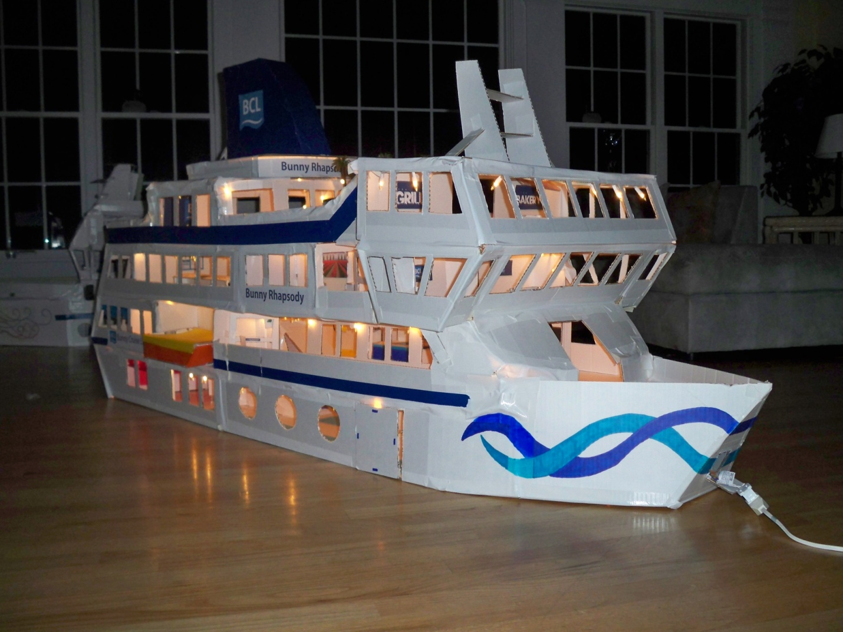

BY: MIKEY FAUST

THE BASICS – WHAT YOU WILL NEED
To start building your cruise ship (pictured on front page), you are going to need a few basic items first. For the type of ship you will be building, you will need...
- 10-11 pieces of all white science fair tri fold poster board
- 5-6 rolls of white duct tape
- A straight edge
- 3-4 rolls of scotch tape
- 1 package of colored construction paper
- Scissors
- Pencil, pen, sharpies, markers, etc.
- Ruler and/or tape measure
- Computer w/ printer for signage (optional)

All of these materials should cost around $80 to $100, and can be found at most local craft stores.

HOW TO BUILD IT
Most of the ship will have to be built using your own creativity and imagination, but I want to give you a few tips on how to build your new ships.
- To maximize the use of the cardboard, use the larger middle section of the tri fold board as the flooring and the side panels as the walls, but make sure to cut the side panels off first so you can draw on them, and put designs on them!
- My wall heights on my ships are usually about 6” but feel free to make them any size.
- To make a circular porthole window, trace the inside of one of the rolls of cut tape on the wall piece, and cut it out with a knife.
- Make sure that there is enough room for your small pet to move around on the inside, or they may not enjoy it.
- Always make sure that the stairwell is centrally located and easily accessible so they can find it. For the stairwell you may want to use a ramp or small ramp, platform, small ramp design.
- For maximum room in your ship, do not put chairs on the rooms as they take up too much room, but feel free to add tables!
- Some room ideas would include a dining room, a comedy club, theater, bars, more restaurants, lounges, bowling alley/bar, cafes, nightclub, spa, gym, etc...
- The hull (front of ship) is mad bay cutting out a triangle as the base, and then creating walls that are about 8” tall for the left and ride side of the triangle base with a curve in the front of each piece, and then join them together.
- FOR FURTHER QUESTIONS PLEASE FEEL FREE TO EMAIL ME AT: MIKEYSCRUISEBLOG@GMAIL.COM OR SEND US A MESSAGE AT BUNSHIPS.WEEBLY.COM UNDER THE REVIEWS PAGE.

DON’T FORGET TO SEND IN PICTURES OF YOUR SHIP TO THE EMAIL ADDRESS ABOVE TO BE FEATURED ON OUR WEBSITE!

